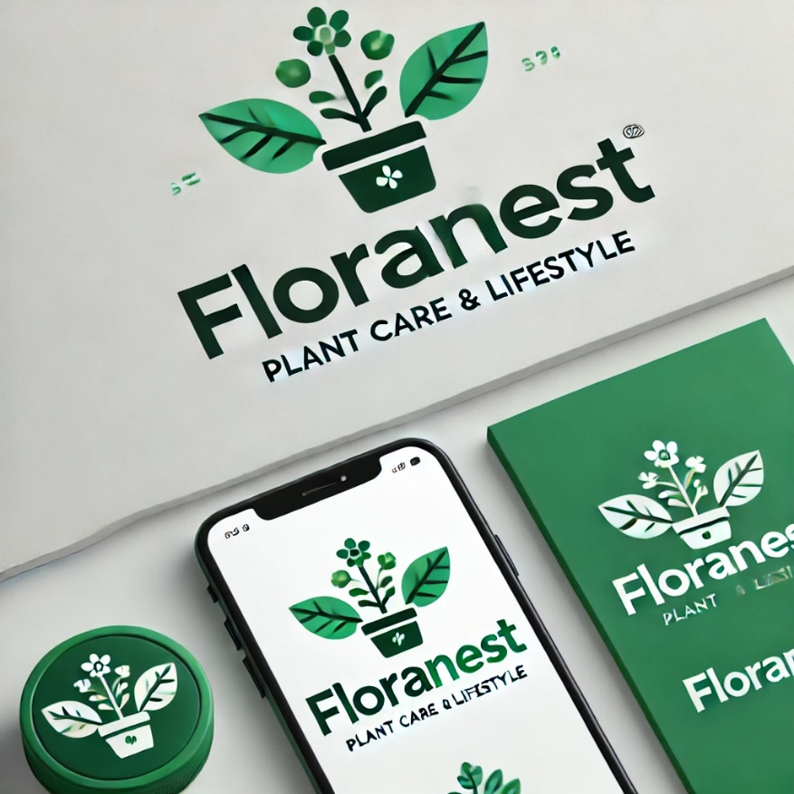

**Flora Nest Project Report**

**Prepared By:**

**Wrood Fawaz ALlibdi 2112158**

***Supervised By:***

**[Dr. Hela Hachicha]**

Table of Contents

1. Introduction 3

1.1 Project Overview: 3

1.2 Objectives: 3

2. Scope 3

2.1. The Current Situation 3

3. Development Environment 4

3.1 Tools: 4

3.2 Languages and Frameworks: 4

Project Initiation 5

Story Backlog 6

Prioritize Stories and Define Sprints: 7

User Interfaces: 8

## 1. Introduction

### 1.1 Project Overview:

**Flora Nest** is an Android app designed to bring plant enthusiasts together, allowing them to exchange information, tips, and experiences about plant care. It provides comprehensive information about different plant types, including cultivation methods, care tips, and benefits, along with an interactive forum and Google Maps integration.

### 1.2 Objectives:

* + - To offer detailed information about plant types.
    - To facilitate community interaction through an integrated forum.
    - To help users locate nearby nurseries using geolocation features.

## 2. Scope

### 2.1. The Current Situation

* **Overview**: Imagine you’re someone who loves plants—whether you’re a beginner or a seasoned gardener. You want to find information about different plants, how to care for them, and maybe discover some new varieties. You’d also love a place to connect with others who share your passion, exchanging tips and experiences. However, finding all this in one place isn’t easy. Right now, plant lovers have to jump between different websites, social media groups, and forums. It’s frustrating when you want a simple, reliable resource that brings everything together.
* **Problem**: What’s missing is a single, go-to app that not only provides detailed plant information but also fosters a community where plant lovers can interact, share experiences, and get practical advice. Additionally, users want the convenience of locating nearby nurseries to buy plants, but this feature is often overlooked in existing platforms. **FloraNest** aims to fill this gap by creating an all-in-one solution.

## 3. Development Environment

### 3.1 Tools:

* Android Studio for Android app development.
* GitHub for version control.
* Firebase for backend services.

### 3.2 Languages and Frameworks:

* Java/Kotlin for coding.
* XML for UI design.
* Google Maps API for geolocation.
* **Jira**: For task management, sprint planning, and tracking project progress using Agile methodology.

## Project Initiation

**Project Name**: FloraNest  
**Project Members**: Wrood , Razan , Razan

**Project Description**

**FloraNest** is an Android app designed to bring plant enthusiasts together in one place. The app aims to provide detailed information about different plant types, foster community interaction through an integrated forum, and help users locate nearby nurseries using Google Maps. It addresses the current lack of a centralized platform where users can find reliable plant information, interact with other plant lovers, and access local plant resources.

**Intended Functionalities**

* **User Registration & Login**: Create an account, verify email, log in, and manage user profiles.
* **Plant Information Display**: Browse detailed information about plants, including images, care tips, and benefits.
* **Interactive Forum**: Create posts, comment, and engage with other users.
* **Google Maps Integration**: Find nearby nurseries using geolocation.

## Story Backlog

|  |  |  |  |  |  |  |
| --- | --- | --- | --- | --- | --- | --- |
| Component Name | Story Name | Story Sequence No | Client Role | Developers | Story Short Description | Story Long Description |
| Registration | Registration | 001 | Wrood | Razan 1, Razan 2 | Users can register as new members of the FloraNest community | Users will be able to enter their personal information, such as name, email, password, and city, to create an account. Email verification will be required to complete registration, and user data will be securely stored in Firebase. |
| Login and Authentication | Login | 002 | Wrood | Razan 1, Razan 2 | Users can log in using their registered email and password | The system will authenticate users based on their credentials stored in Firebase. |
| Plant Information Display | Plant Info Display | 003 | Razan 1 | Razan 2, Wrood | Users can browse different plant types | Users will be able to see detailed information about various plants, including images, descriptions, cultivation tips, care advice, and benefits, organized by categories. |
| Forum | Forum Posts | 004 | Razan 2 | Razan 1, Wrood | Users can create posts to share their plant experiences | Users can create, comment, and like posts in the forum to interact with other plant enthusiasts. Posts can include text and images. |
| Google Maps Integration | Google Maps | 005 | Wrood | Razan 1, Razan 2 | Users can find nearby nurseries | The app uses geolocation to show nearby nurseries on Google Maps. Users can view details and get directions. |

## Prioritize Stories and Define Sprints:

1. **Sprint 1:**

Registration (Story 001)

Login & Authentication (Story 002)

1. **Sprint 2:**

Plant Information Display (Story 003)

1. **Sprint 3:**

Forum Posts (Story 004)

1. **Sprint 4:**

صورة تحتوي على نص, لقطة شاشة, برمجيات, أيقونة الحاسوب

تم إنشاء الوصف تلقائياًGoogle Maps Integration (Story 005)

## User Interfaces: